L1F22BSCS0028 MUHAMMAD OMAR ZAHID
ASSIGNMENT 1 PROB & STATS

Task1:
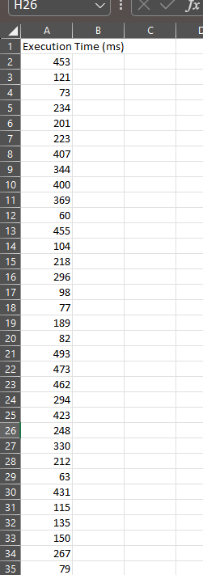
Task 2:

Task3:
- The histogram shows how program execution times are distributed across different ranges. It helps identify whether most execution times are concentrated in a specific range or spread evenly across the dataset.
- The most frequent execution time range is (50-145).
- It shows that system performance differs across the tested computers. The spread of the bars suggests moderate variability in execution time, meaning some systems execute the program faster while others take longer. However, the clustering of values around the middle ranges suggests that most systems provide similar performance.

